Depth Gauge Proof of Concept

Pete Marchetto, Biological and Environmental Engineering Department, Cornell University

# Construction

The depth gauge was constructed from a piece of 2” PVC pipe, 2.5’ long, and cut along its length to give a slit a maximum of 1/8” wide. This was painted with a flat black spray paint, and contained a standard 40 mm ping-pong ball, and at its top, a model GP2Y0A02YK0F distance sensor (Sharp, Mahwah, NJ, USA) mounted to a polycarbonate spacer under a 2” PVC end cap.

# Test Method

The depth gauge was put into a 35-gallon barrel along with a model 06-808C staff gauge (CST/berger, Watseka, IL, USA), which was clamped to its side. Water was added several inches at a time, and measurements of the gauge were taken using a RedBoard Arduino clone microcontroller (SparkFun, Boulder, CO, USA). The depth according to the gauge was recorded, along with the rough average reading from the serial monitor data from the Arduino. The test setup can be seen in fig. 1.

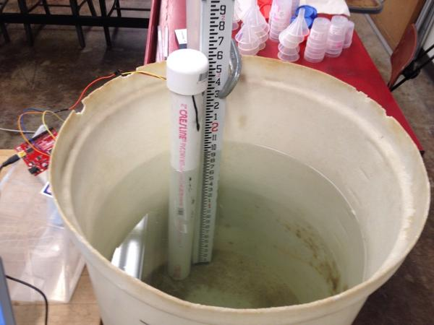

Fig. 1: Test setup for depth gauge.

# Results

The results are encouraging, even with this very rough test. As seen in fig. 2, there is a deterministic linear function that allows for conversion of reading in LSBs to depth in inches. The R2 value of over 97% is also very encouraging, given the rough nature of the testing equipment.

Fig. 2: Depth gauge output as a function of depth in a functional test.

# Conclusion and Further Work

This system is worth pursuing further, and needs further testing in a more controlled setting. An integration and averaging function might be of use to smooth out the more transient depth changes that come with a current, and a longer cord will allow for more space between the gauge and its electronics.